Software Requirements Specification
Environmental Health Regulatory Case Management System (EHRCMS) — Rivers State of Nigeria, Public Health Law Cap 106
Document status | Draft 2 — for stakeholder review
Prepared following | IEEE 830 / ISO/IEC/IEEE 29148
Date | 7th September 2026

Table of Contents
Table of Contents 1
1. About this document 1
2. What the system is for 1
3. Rules that apply to everything 1
4. Fitness Certificate — for people 1
5. Fumigation Certificate — for the premises 1
6. Inspection Notices 1
7. Health Approval — for the business 1
8. Seeing everything about one premises 1
9. Money: prices, payment, and the split 1
10. Settings each council can change 1
11. Screens and outside connections 1
12. Quality requirements 1
13. Information the system keeps 1
14. Still to confirm 1
Appendix A — The two inspection checklists in use today 1

1. About this document

1.1 Why it exists
The Ministry and the local government health departments issue four documents under the Public Health Law, Cap 106. Today the work is done on paper. This document describes the software that will do it instead.
It is written to be read by two different groups at once:
- Officers, managers, and decision-makers. The plain paragraphs explain what the system does and why. You can read only those and still understand the whole system.
- The development team. The numbered lines in the tables are the build list. Each one starts with “The system must…” and each has a reference like FR-MCF-004 so it can be tracked, tested, and signed off.
If the two ever seem to disagree, the numbered line is the requirement.

1.2 Why this has to be built carefully
The documents this system produces are legal documents. They are used to close premises, to prosecute defaulters, and to defend a business on appeal. So the system has to do more than store data. For every certificate and notice it must be able to show, later and to a stranger:
- who did it,
- when they did it,
- what rule was in force at the time,
- and that nothing has been quietly changed since.
That requirement shapes most of the design decisions in this document.

1.3 Words used here
Word | What it means here
Council | A local government area health department or authority. Also called a jurisdiction, because the system is built so that other bodies can use it too
MOH | Medical Officer of Health, or the Director signing on their behalf. The person who approves and signs certificates
EHO | Environmental Health Officer. The officer who inspects premises and supervises fumigation work
Board | Rivers State Primary Health Care Management Board
Applicant | The business, premises owner, or individual asking for a certificate
Facility | An approved clinic or laboratory that carries out food handler medical tests
Provider | A licensed pest control outfit that carries out fumigation and rodent control
Fitness Certificate | Medical Certificate of Fitness for Food Handlers. Covers people
Fumigation Certificate | Certificate of Fumigation and Deratization. Covers a place
Health Approval | Health Approval Certificate. Covers a business
Inspection Notice | Notice of Environmental Health Inspection. Tells a premises that officers are coming
Supporting document | Something the applicant must supply that this system does not produce, such as a water analysis result
Settings | Anything a council can change for itself without new software being written
NDPA | Nigeria Data Protection Act 2023, and the GAID 2025 directive made under it

1.4 What has not been checked
Nobody has yet compared this document against the printed text of Cap 106. Every legal point in it — which section authorises what, how long a certificate lasts, how much notice a premises must be given — comes from how the departments work today. Each one is marked, and all of them are gathered in Section 14 so the legal officer can work through them in one pass.

2. What the system is for

2.1 The problem today
Everything is on paper. A certificate can only be checked by telephoning the office that issued it. There is no easy way to see whether a business is fully compliant, because the three certificates that would tell you sit in three different files, sometimes in three different offices. Money changes hands for medical tests and fumigation work with no central record of what was charged or who received it.

2.2 Who uses the system
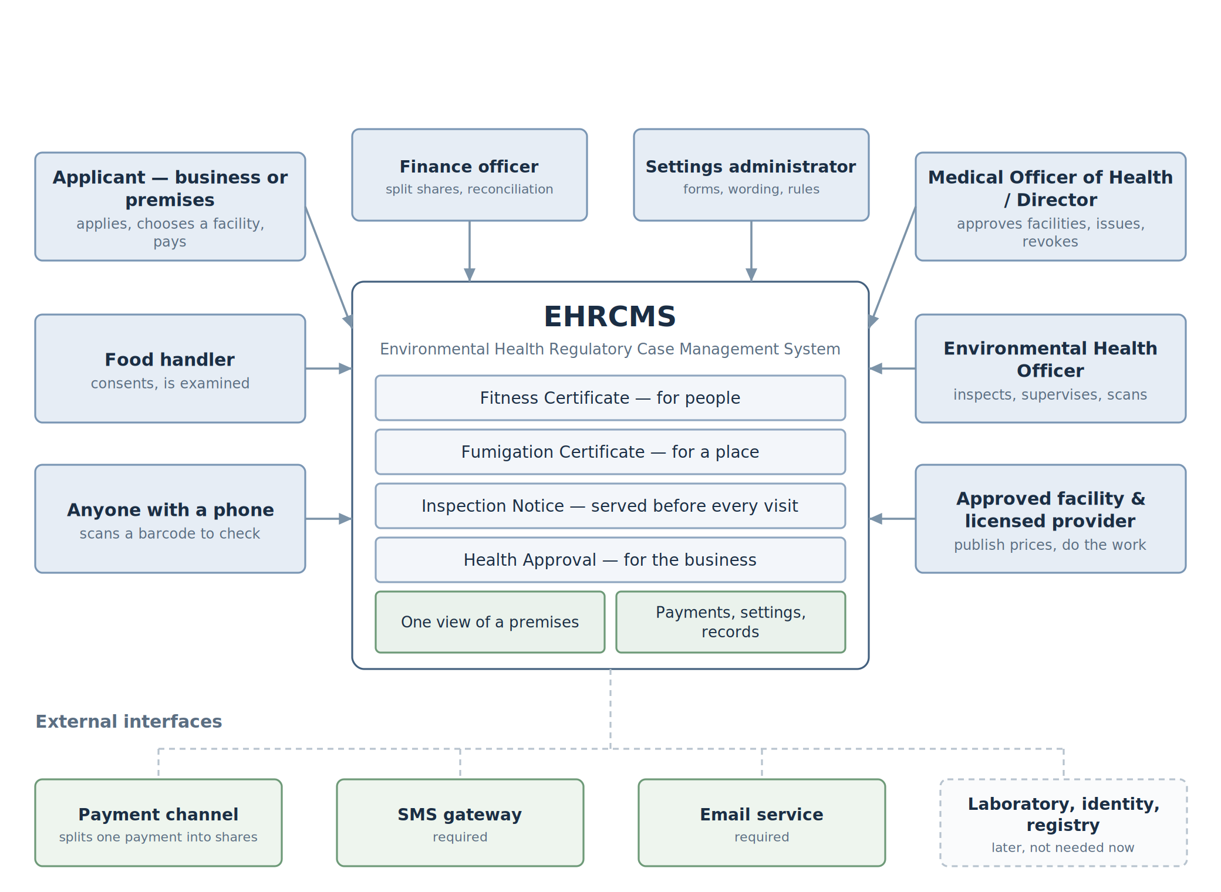
Figure 1 — Who uses the system, and what it connects to.
Who | What they do
Applicant — a business, premises owner, or food handler | Applies, chooses a facility, pays, uploads documents, tracks progress, renews
Approved facility | Publishes its services and prices, offers appointment times, carries out medical tests, records the result
Licensed provider | Publishes its services and prices, offers appointment times, carries out fumigation, completes the job report
Environmental Health Officer | Serves notices, inspects premises, supervises fumigation work
Medical Officer of Health / Director | Approves facilities and providers, approves their prices, decides applications, signs and issues certificates, suspends and revokes
Finance officer | Sets up how each payment is split, reconciles the money, handles refunds
Settings administrator | Changes the council’s own settings: forms, wording, time limits, split ratios
Supervisor | Ministry or Board level. Reads and reports across councils. Issues nothing
System administrator | Manages user accounts. Issues nothing
Anyone with a phone | Scans the barcode on a certificate to check whether it is real and still valid

2.3 The four documents
The three certificates cover three different things, and mixing them up is the most common mistake in a system like this. One covers people, one covers a place, and one covers the business. The third can only be honest if the first two are already true, which is why nobody applies for it.
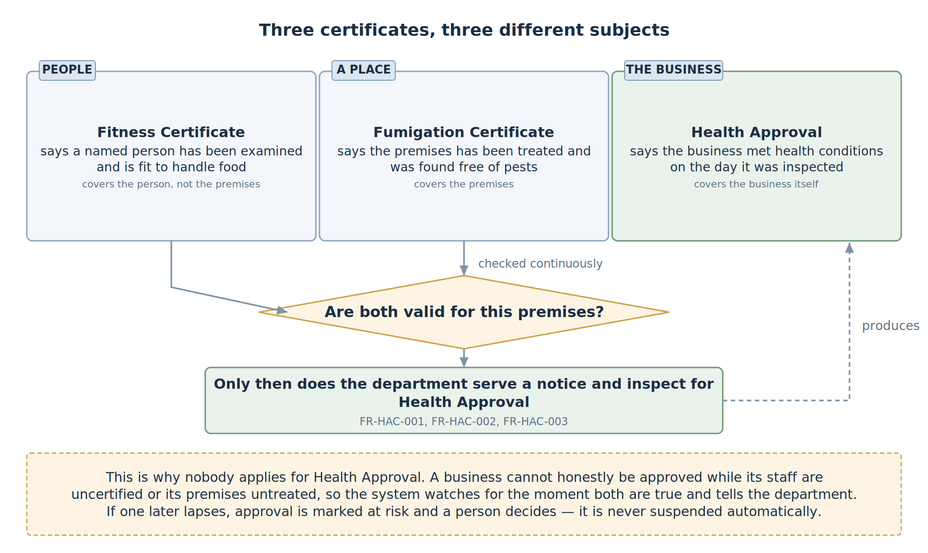
Figure 2 — What each certificate covers, and why Health Approval depends on the other two.
Document | Covers | Who starts it | Who does the work | Who signs
Fitness Certificate | Named people | The employer, or the person | An approved facility chosen by the applicant | MOH
Fumigation Certificate | The premises | The premises | A licensed provider chosen by the applicant, watched by an officer | MOH
Inspection Notice | Nothing — it announces a visit | The department | Officers | Director / MOH
Health Approval | The business | The department, once the first two are valid | Officers, at an inspection | MOH

2.4 What the system does and does not do
It does: register businesses, premises, and food handlers; take applications; show the approved facilities and their prices so the applicant can choose; take one payment and split it automatically; book appointments; record test results, fumigation reports, and inspection findings; produce every certificate and notice with a barcode; send notices by email and SMS and record the reply; track expiry and renewal; suspend and revoke; let anyone check a certificate; let each council change its own settings; and keep a permanent record of everything.
It does not: issue documents that other bodies produce, such as water analysis results, registration certificates, seminar certificates, or building permits — these are uploaded and checked, not created here. It does not run court cases after enforcement. It is not an accounting system, although it records every naira collected and split, and produces reports for the people who do the accounting. It is not a medical records system.

3. Rules that apply to everything
Whatever kind of certificate it is, it moves through the same stages, and the same protections apply.
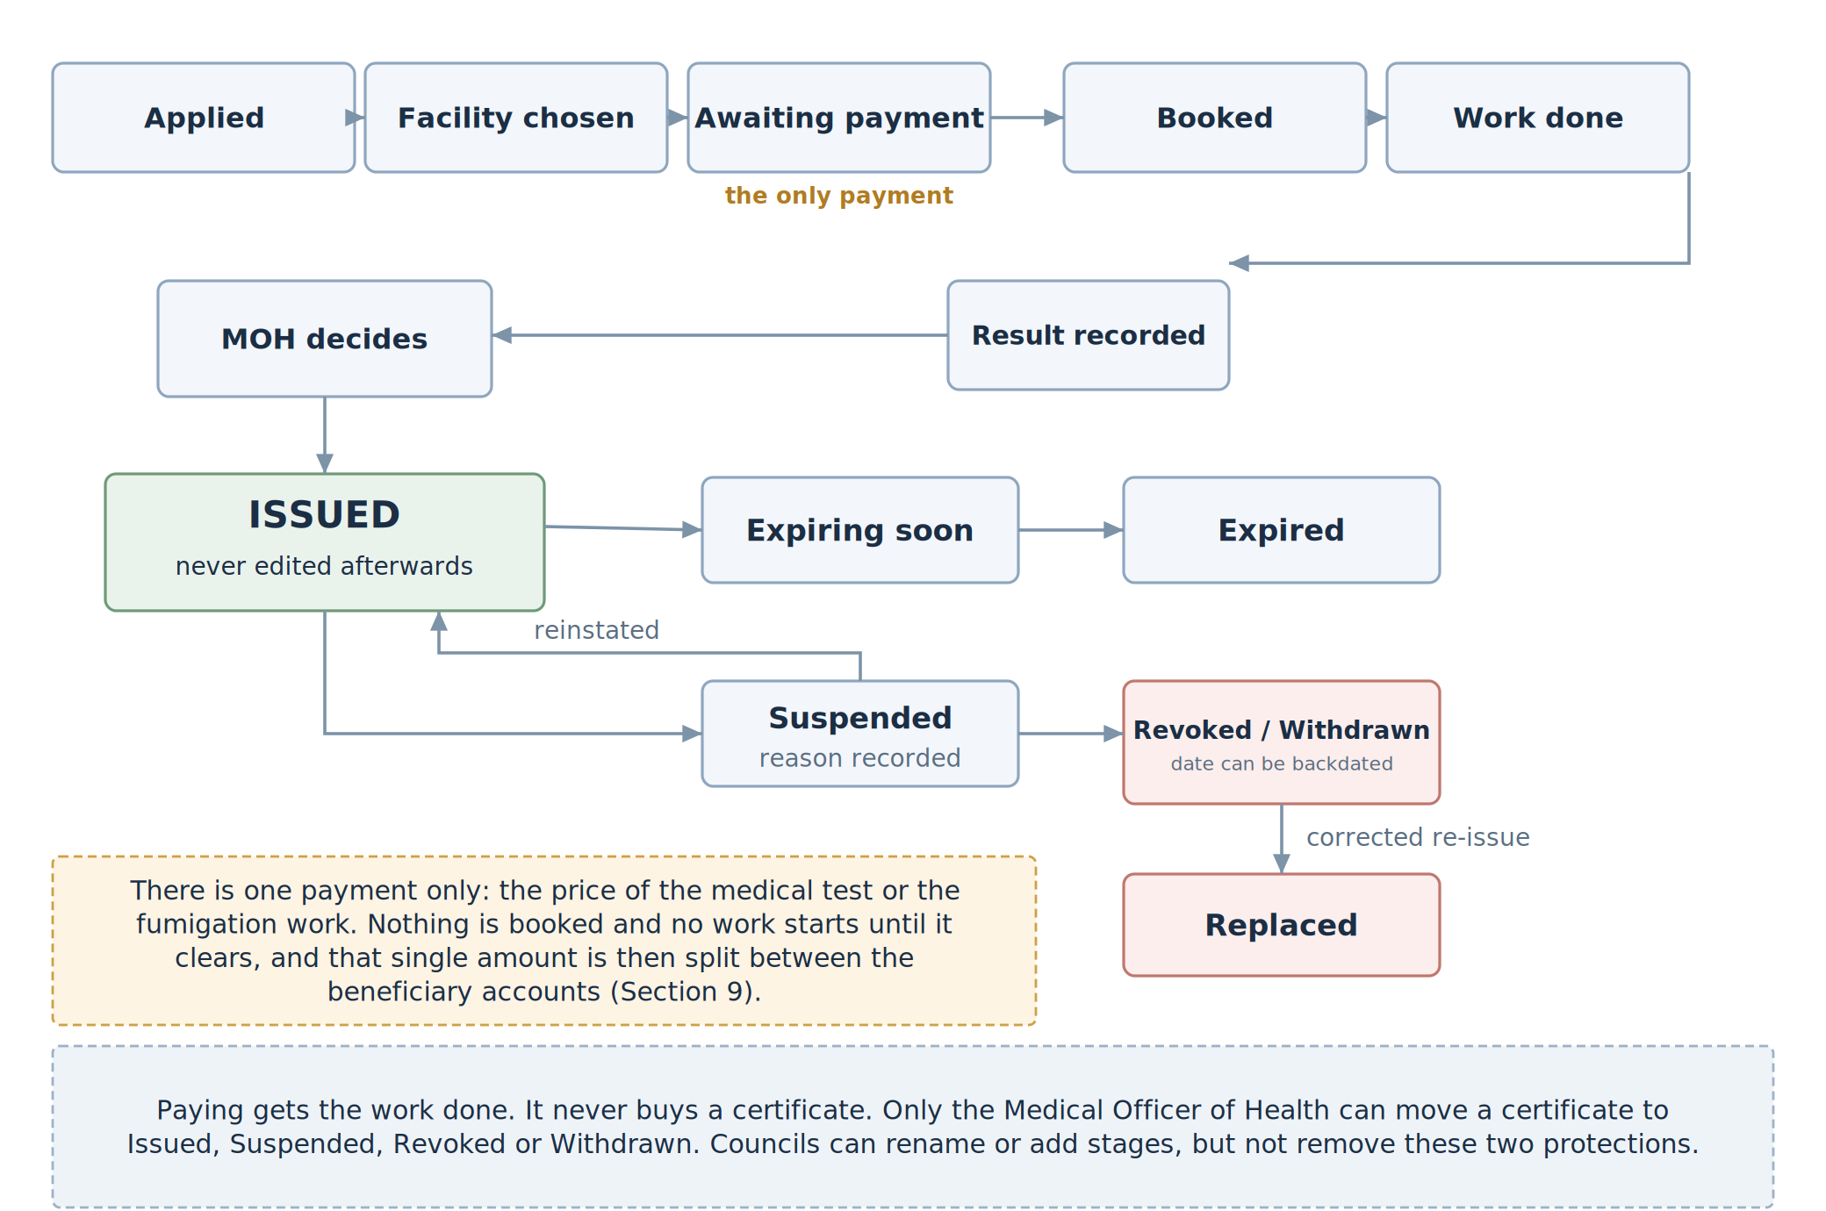
Figure 3 — The life of a certificate, and the one point where payment holds it up.
Two protections matter more than the rest, and neither can be switched off by any council:
- Only the MOH can issue, suspend, or revoke. No administrator, no automatic process, and no payment can do it instead.
- A payment buys a decision, not a certificate. Paying for a medical test entitles the applicant to be tested and to have their application decided. It does not entitle them to pass.
Ref | The system must…
FR-GEN-001 | Give every certificate and notice its own number, unique across every council, that reveals nothing private about the person or business.
FR-GEN-002 | Also print the council’s own reference in whatever format that council uses.
FR-GEN-003 | Print a barcode on every certificate, notice, and receipt, big enough to still scan after printing and photocopying, with a short code printed next to it for anyone who has no scanner.
FR-GEN-004 | Print the correct legal reference for that council, taken from settings rather than fixed in the software.
FR-GEN-005 | Record three separate dates: the day the work was done, the day the certificate was issued, and the day it expires. These are not the same date and must never be merged.
FR-GEN-006 | Work out the expiry date from that council’s rule, and show which rule was used. Only the MOH may override it, and only with a written reason.
FR-GEN-007 | Use the stages shown in Figure 3. A council may add or rename stages in settings, but not remove the two protections above.
FR-GEN-008 | Lock a certificate once issued. A mistake is fixed by cancelling it and issuing a new one, linked to the old. Nothing issued is ever edited.
FR-GEN-009 | Warn the applicant and the office before a certificate expires, at whatever notice period the council sets.
FR-GEN-010 | Let a certificate be renewed by starting a fresh application filled in from the old one. Renewal always produces a new certificate; it never extends the old expiry date.
FR-GEN-011 | Record a reason, a note, the officer, and the time whenever anything is suspended, revoked, or withdrawn.
FR-GEN-012 | Let an applicant object to a refusal, a suspension, or an inspection finding, and record what was decided. [the legal appeal route still needs confirming — Q13]
FR-GEN-013 | Ask for the supporting documents that council requires, and record for each one its type, reference, who issued it, when it expires, a scanned copy, and which officer checked it.
FR-GEN-014 | Hold the work until the service has been paid for (Section 9).
FR-GEN-015 | Record the pre-printed serial number where old certificate paper is still being used, and flag it if the same serial is entered twice.
FR-GEN-016 | Stamp every record with the settings version in force when it was created, so that changing a setting tomorrow never changes what a record meant yesterday.

4. Fitness Certificate — for people
This certificate says that a named person has been examined and is fit to handle food. It is about the person, not the premises. The premises is recorded only as where that person works, which is what lets an inspector check the staff actually on site.
How it works. The employer applies and lists the staff. Each person gives consent for their health information to be handled. The system then shows the approved facilities — name, where they are, what they offer, and what they charge — and the applicant picks one. The applicant pays that facility’s price. The facility offers appointment times, examines each person, and records fit, not fit, or refer. The MOH looks at the results and issues the certificate.
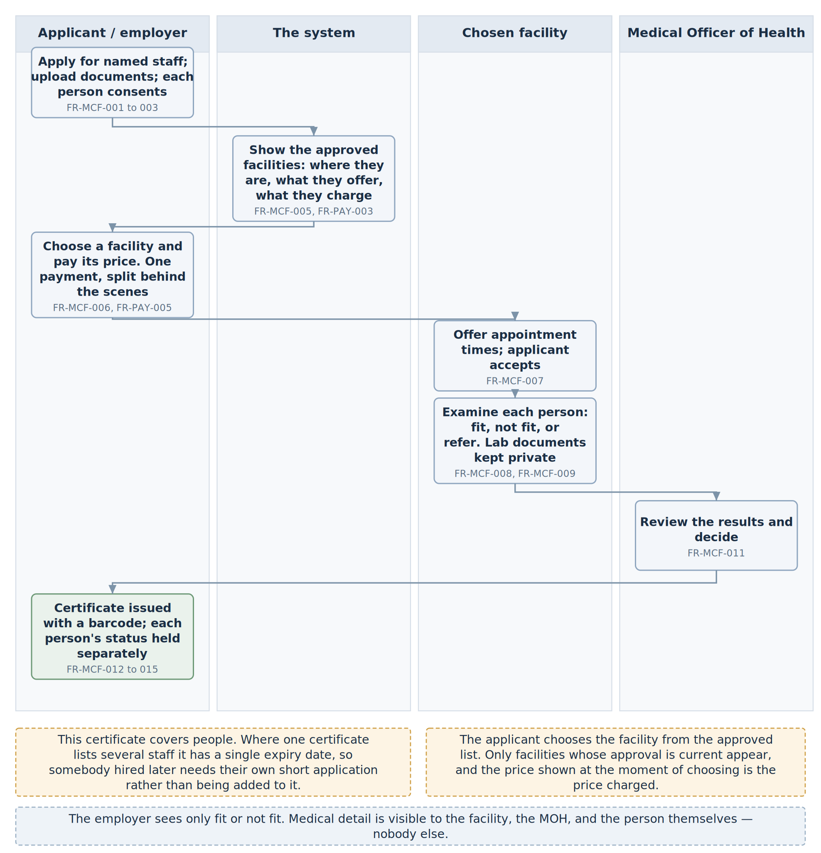
Figure 4 — How a Fitness Certificate is obtained.
Ref | The system must…
FR-MCF-001 | Let an employer, or a food handler acting for themselves, apply for one or more named people.
FR-MCF-002 | Collect whatever the council’s form asks for, and at minimum: who is applying and how to reach them, where the staff work, and for each person their name, sex, date of birth, job, an identity number, and a phone number.
FR-MCF-003 | Get and store each person’s consent to their health information being handled, before any appointment is booked.
FR-MCF-004 | Keep a register of approved facilities, each with its address and location, the services it offers, its approved prices, its approval status, and when that approval runs out.
FR-MCF-005 | Show the applicant the approved facilities and let them choose. The list must show each facility’s name, address, distance or area, services, price, and next available appointment. Only facilities whose approval is current may appear.
FR-MCF-006 | Record which facility was chosen, by whom, and when. Nobody may choose on the applicant’s behalf except a counter officer helping them, and that must be recorded too.
FR-MCF-007 | Let the chosen facility offer appointment times and the applicant accept one, and tell both sides.
FR-MCF-008 | Let the facility record the result for each person separately as fit, not fit, or refer, with the examining clinician, the date, and the tests done. [the required tests still need confirming — Q7]
FR-MCF-009 | Let the facility attach laboratory documents to a person’s record. These may be seen only by the facility, the MOH, and the person themselves — never by the employer, never on the certificate, never by anyone checking a barcode.
FR-MCF-010 | Never tell the employer, or anyone checking a certificate, why somebody was found unfit. Only fit or not fit is shared.
FR-MCF-011 | Stop the MOH issuing while anyone on the application is still marked refer, unless the MOH takes that person off the certificate and says why.
FR-MCF-012 | Print the certificate with the wording, the council, the reference, the barcode, the dates, and the MOH’s name and signature block.
FR-MCF-013 | Set the expiry from the council’s rule. The usual rule is six months from the day it is issued. [confirm — Q8]
FR-MCF-014 | Keep a record of each person’s fitness that stands on its own, so their status can be found even if they change employer.
FR-MCF-015 | Where one certificate lists several people, hold the status person by person, so one person can be revoked without cancelling the certificate for everyone else.
FR-MCF-016 | Treat a person hired after the certificate was issued as a new short application producing their own certificate. An issued certificate is never quietly added to.

5. Fumigation Certificate — for the premises
This certificate says a place has been treated and was free of pests on the day the work was done.
How it works. The premises applies. The system shows the licensed providers with their locations, services, and prices, and the applicant picks one and pays. The provider offers a date, does the work while a council officer watches, and files a job report. The officer confirms the report. The MOH issues the certificate.
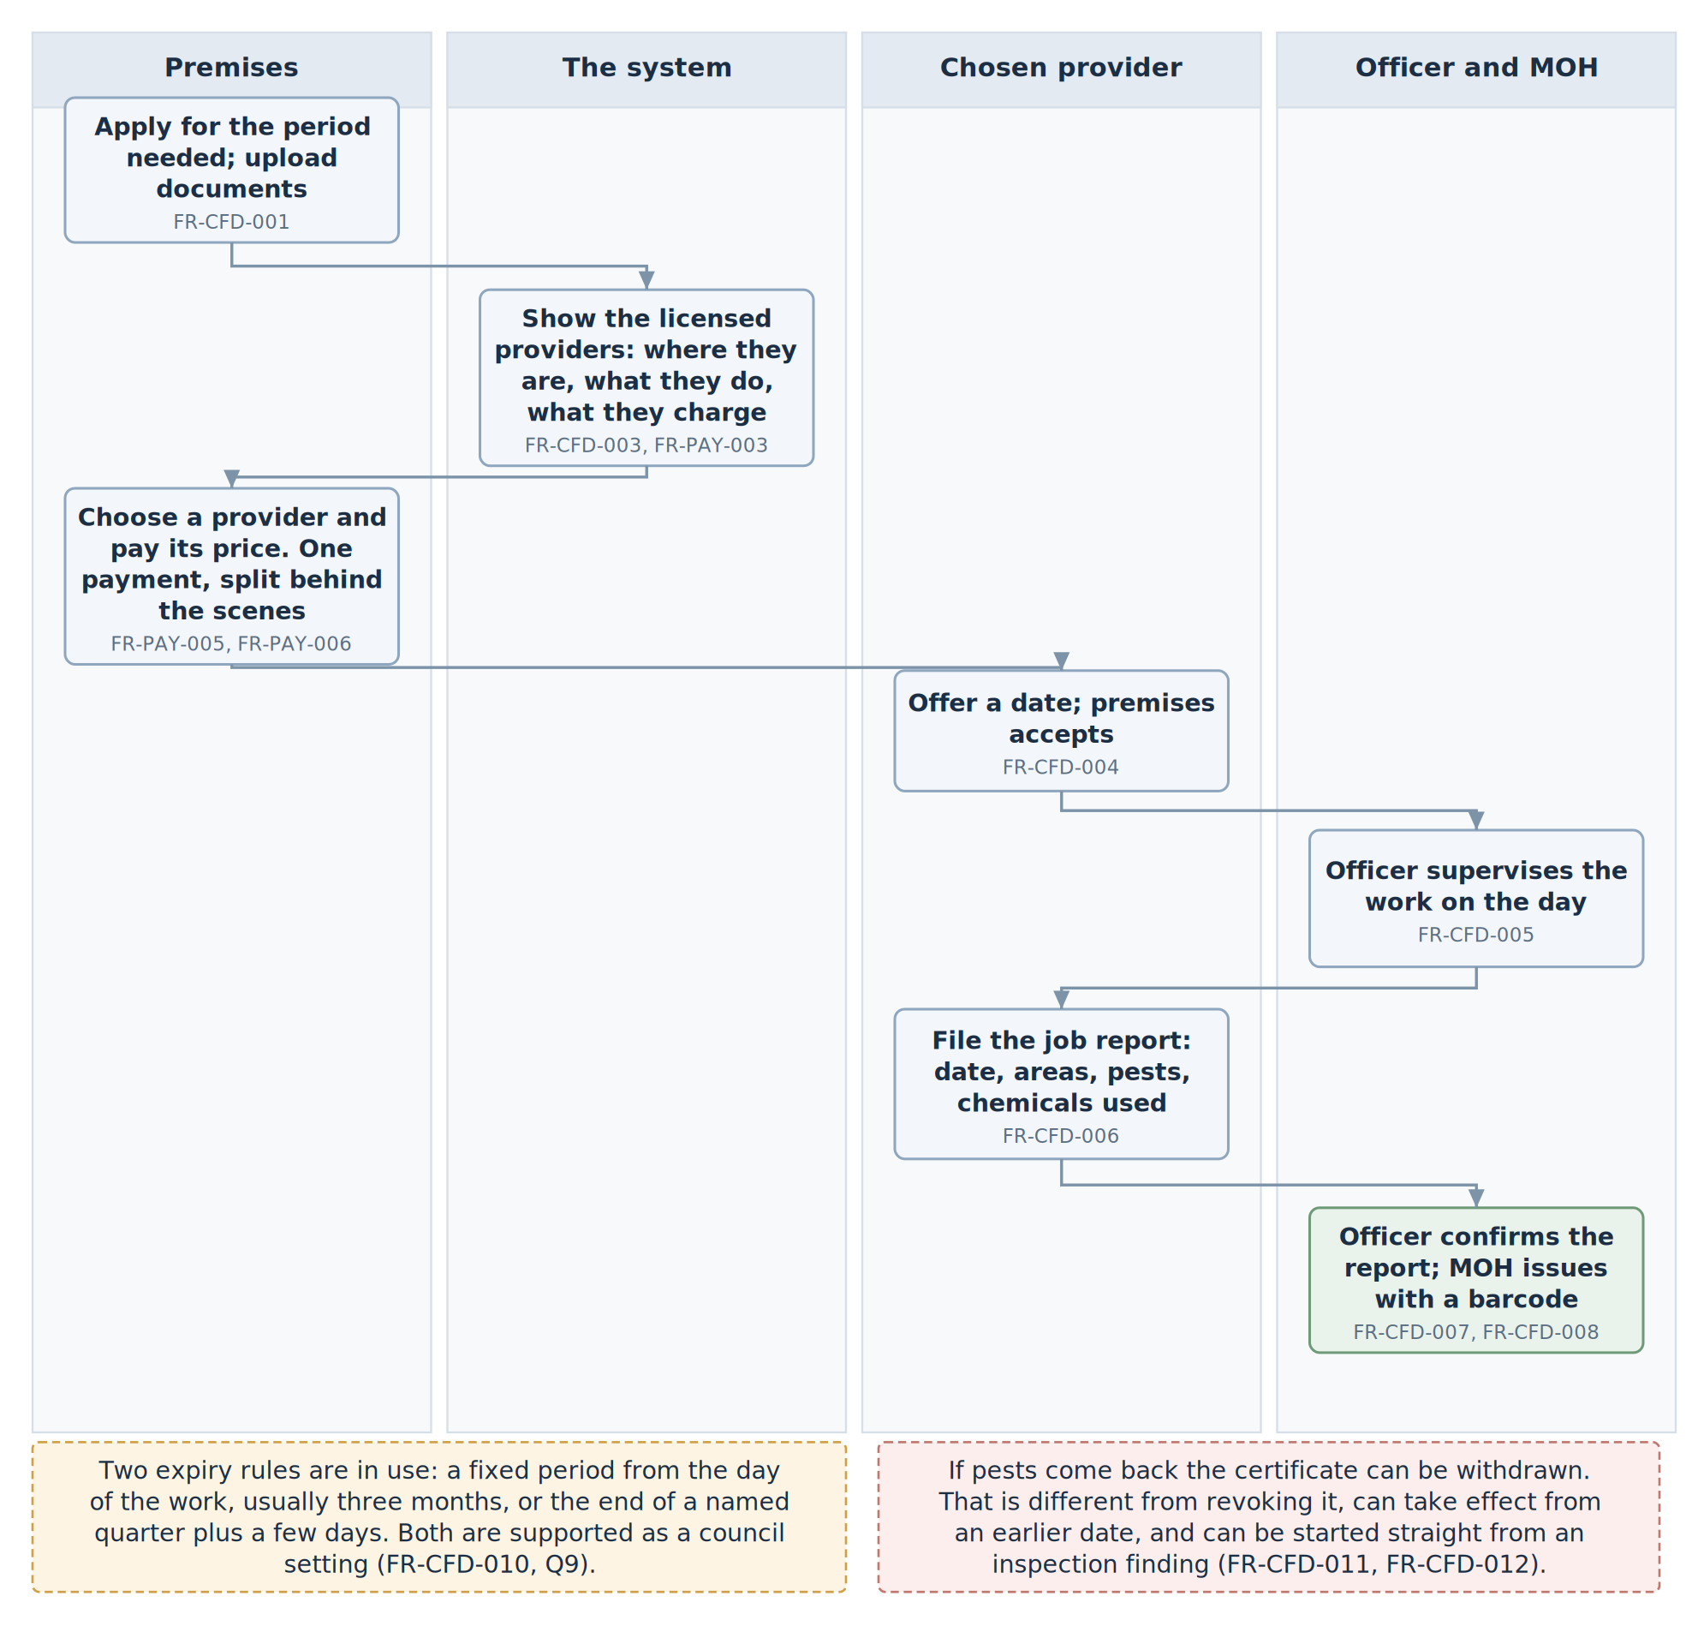
Figure 5 — How a Fumigation Certificate is obtained.
Ref | The system must…
FR-CFD-001 | Let a premises apply, collecting the council’s fields and at minimum the premises name, address, council, type of premises, contact details, and the period being covered.
FR-CFD-002 | Keep a register of licensed providers, each with its registered name, EHO registration number, address, services, approved prices, licence status, and licence expiry.
FR-CFD-003 | Show the applicant the licensed providers and let them choose, in the same way as facilities at FR-MCF-005. A provider whose licence has run out or been suspended must not appear.
FR-CFD-004 | Let the chosen provider offer a date and the premises accept it, and tell both sides.
FR-CFD-005 | Record which officer supervised the work. The certificate states that the work was supervised, so this is a fact being certified and must be captured, not assumed.
FR-CFD-006 | Let the provider file a job report giving the date, the areas treated, the pests targeted, the chemicals or methods used and their strength, who carried out the work, and a signed declaration.
FR-CFD-007 | Let the supervising officer confirm or dispute that report before the MOH sees it.
FR-CFD-008 | Print the certificate naming the premises and address, the provider and its registration number, the date of the work, the supervising office, the legal reference, the barcode, and the declaration that the premises was found free of pests.
FR-CFD-009 | Keep the date of the work, the date of issue, and the expiry date as three separate dates, and show in words what period the certificate covers.
FR-CFD-010 | Work out expiry from the council’s rule. Two rules are in use today and both must work: a fixed period from the day of the work, usually three months; or the end of a named quarter plus a few days. [confirm which council uses which — Q9]
FR-CFD-011 | Allow the certificate to be withdrawn if pests come back. This is different from revoking it, needs evidence on the record, and can be started straight from an inspection finding.
FR-CFD-012 | Let the MOH set the date a withdrawal takes effect, which may be earlier than the day the decision was made, and show that date to anyone checking.
FR-CFD-013 | Keep the fumigation history of each premises, so an officer can see whether the same place keeps getting reinfested.

6. Inspection Notices
A premises is never inspected without being told first. The notice is served, the recipient acknowledges it, and only then can officers visit and record findings. This applies to every kind of inspection, including the one that leads to a Health Approval. The system enforces it: an inspection with no served notice behind it cannot be recorded at all.
The notice is also the moment everything else gets checked, because the fumigation certificate, the fitness certificates, and the health approval all appear on the inspection checklist.
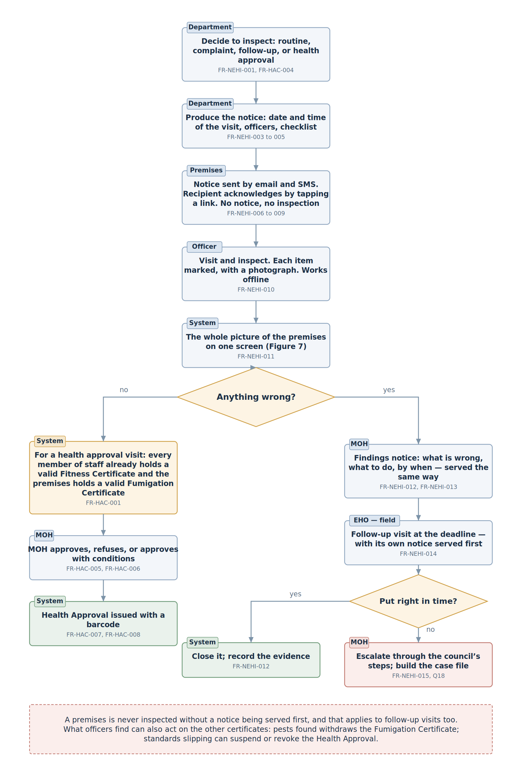
Figure 6 — Inspections, and how a Health Approval follows from one.
Ref | The system must…
FR-NEHI-001 | Support three kinds of inspection: routine, complaint-driven, and follow-up. A council may add its own kinds in settings.
FR-NEHI-002 | Let the department schedule inspections in bulk — a whole street, ward, or type of premises — and produce a notice for each one.
FR-NEHI-003 | Print on the notice the addressee and address, the period, the date and time officers will come, the names of the officers, the reference, the barcode, and the date of the notice.
FR-NEHI-004 | Print the checklist of what will be looked at, taken from the council’s checklist template. The two checklists in use today are in Appendix A.
FR-NEHI-005 | Print the warning and cooperation wording that council uses.
FR-NEHI-006 | Send the notice by email and by SMS, and also produce a printed copy for hand delivery where there is no email or phone number on file.
FR-NEHI-007 | Let the recipient acknowledge it electronically by tapping a link, and record who acknowledged it, on which channel, at what time, and send them a confirmation.
FR-NEHI-008 | Where nobody acknowledges within the time the council sets, try the next channel and record every attempt and its result. Silence is recorded as silence — it is never treated as though the notice had been received. [whether email and SMS count as proper legal service still needs confirming — Q5]
FR-NEHI-009 | Refuse to record an inspection unless a notice for it has been issued and served. There is no override for this.
FR-NEHI-010 | Let the officer mark each checklist item satisfactory, a contravention, not applicable, or not able to check, with a note and a photograph.
FR-NEHI-011 | Show the officer the live status of any certificate the checklist asks about, and fill that item in automatically, so nothing has to be taken on trust from a piece of paper.
FR-NEHI-012 | Record, for every contravention, what must be put right and by when.
FR-NEHI-013 | Produce a findings notice listing the contraventions, what must be done, and the deadlines, and serve it the same way as the first notice.
FR-NEHI-014 | Book the follow-up inspection automatically at the deadline. That follow-up also needs its own notice served first.
FR-NEHI-015 | Support the council’s escalation steps where a premises still does not comply, recording who decided what at each step, and building a file that can be handed to whoever takes the case forward.
FR-NEHI-016 | Record which officers actually attended, which may differ from those named on the notice, and keep both lists.
FR-NEHI-017 | Work offline in the field and upload when there is signal again (Section 12.4).

7. Health Approval — for the business
This is the only certificate nobody applies for, and there is a good reason. A business cannot honestly be approved while its staff are uncertified or its premises untreated. So the system watches for the moment both of those are true, tells the department, and the department then serves a notice, inspects, and decides.
Ref | The system must…
FR-HAC-001 | Keep checking, for every premises, whether all its food handlers hold a valid Fitness Certificate and the premises holds a valid Fumigation Certificate. A council may add further conditions in settings.
FR-HAC-002 | Put a premises on the department’s work list as soon as it qualifies, and tell the MOH.
FR-HAC-003 | Show the premises its own status and what is still missing, but not let it apply for Health Approval directly.
FR-HAC-004 | Have the MOH schedule the approval inspection, which follows Section 6 in full, including serving the notice first.
FR-HAC-005 | Show the MOH the completed checklist, the officer’s recommendation, and the state of the two underlying certificates before any decision is made.
FR-HAC-006 | Let the MOH approve, refuse, or approve with conditions, always with a written reason, and tell the premises the outcome.
FR-HAC-007 | Print on the certificate the legal reference, the date of the inspection, the statement that the premises met the conditions as at the time of inspection, the warning that standards must be maintained, the expiry, the barcode, and the signature block. The words “as at the time of inspection” matter and must not be dropped.
FR-HAC-008 | Set expiry from the council’s rule. The usual rule is 31 December of the year it was issued. [what happens to one issued in November still needs confirming — Q10]
FR-HAC-009 | Let the MOH suspend or revoke it where standards have not been kept up, straight from an inspection finding.
FR-HAC-010 | Where a Fitness or Fumigation Certificate behind it expires or is revoked, mark the Health Approval at risk, tell the premises and the MOH, and put a suspension decision in front of the MOH. It must not suspend by itself. Closing a business is too serious to happen automatically.
FR-HAC-011 | Support the yearly renewal round, including reminders sent in bulk before the expiry date.

8. Seeing everything about one premises
At an inspection, instead of asking for paper and telephoning the office, the officer sees everything about that premises on one screen.
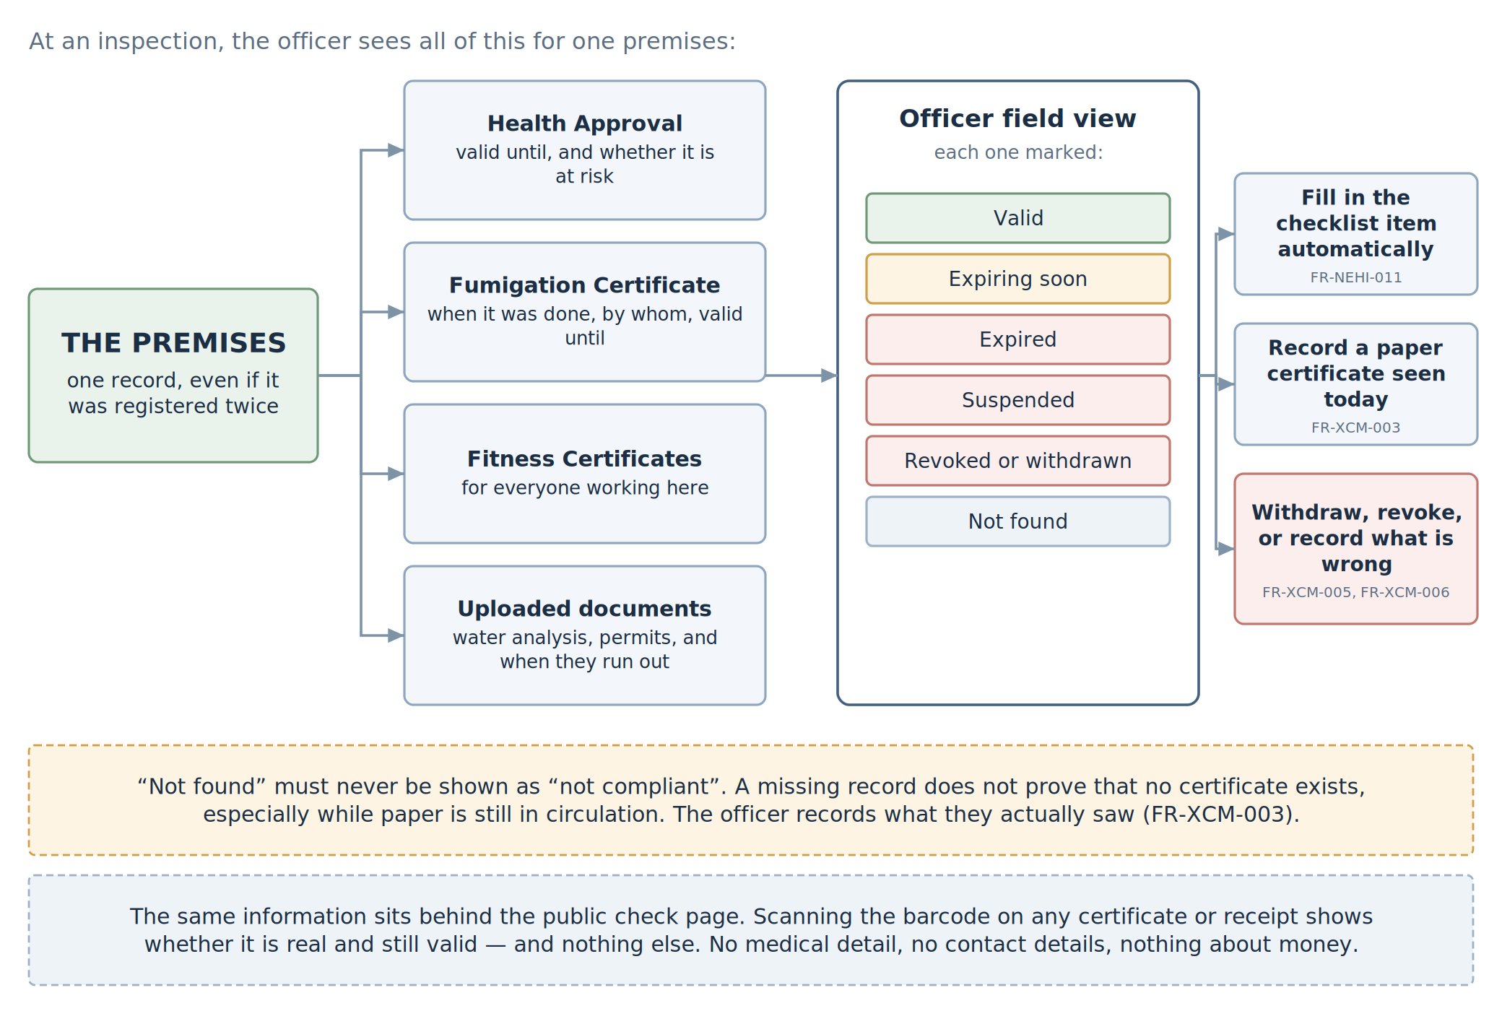
Figure 7 — What the officer sees at an inspection, and what they can do about it.
Ref | The system must…
FR-XCM-001 | Bring together, for one premises: its Health Approval and expiry; its Fumigation Certificate, when the work was done, by whom, and when it expires; the Fitness Certificates of everyone working there; supporting documents and when they run out; the inspection history; and any outstanding contraventions.
FR-XCM-002 | Show all of that in the field, including certificates issued by a different council, marked clearly as valid, expiring soon, expired, suspended, revoked, or not found.
FR-XCM-003 | Never show “not found” as “not compliant”. A missing record is not proof that no certificate exists, especially while paper is still in circulation. The officer must be able to record a paper certificate seen on the day, with its number and who issued it.
FR-XCM-004 | Flag any difference between the staff named on a valid Fitness Certificate and the staff actually working there.
FR-XCM-005 | Let an infestation found at inspection lead straight to withdrawing the Fumigation Certificate, with the inspection record attached as the evidence.
FR-XCM-006 | Let a finding that standards have slipped lead straight to suspending or revoking the Health Approval.
FR-XCM-007 | Provide a public check page where scanning a barcode, or typing the short code, returns the type of document, its number, who issued it, who or what it covers, its dates, and whether it is still valid. It must return no medical information, no phone numbers or addresses, and nothing about money. [whether staff names may be shown publicly still needs confirming — Q12]
FR-XCM-008 | Log every check and limit how many can be run from one place, so nobody can trawl the register.
FR-XCM-009 | Report compliance by premises, ward, council, and state-wide.

9. Money: prices, payment, and the split
There is only one payment, and it is for the service. The applicant pays for the medical test, or for the fumigation work. That is all. No separate fee is paid to the council or to the Board. There is no application fee and no certificate fee.
The price is the facility’s own published price. Each approved facility and licensed provider publishes what it offers and what it charges. The council approves that list before it appears. The applicant sees the list, compares, and chooses.
One payment goes in, several shares come out. When the applicant pays, the system splits that single amount automatically between the accounts set up beforehand — the facility that did the work, the council, the Board, and any other beneficiary. The shares are percentages, they are set in settings, and they must add up to exactly 100%. The applicant sees one price and pays once; the split happens behind the scenes.
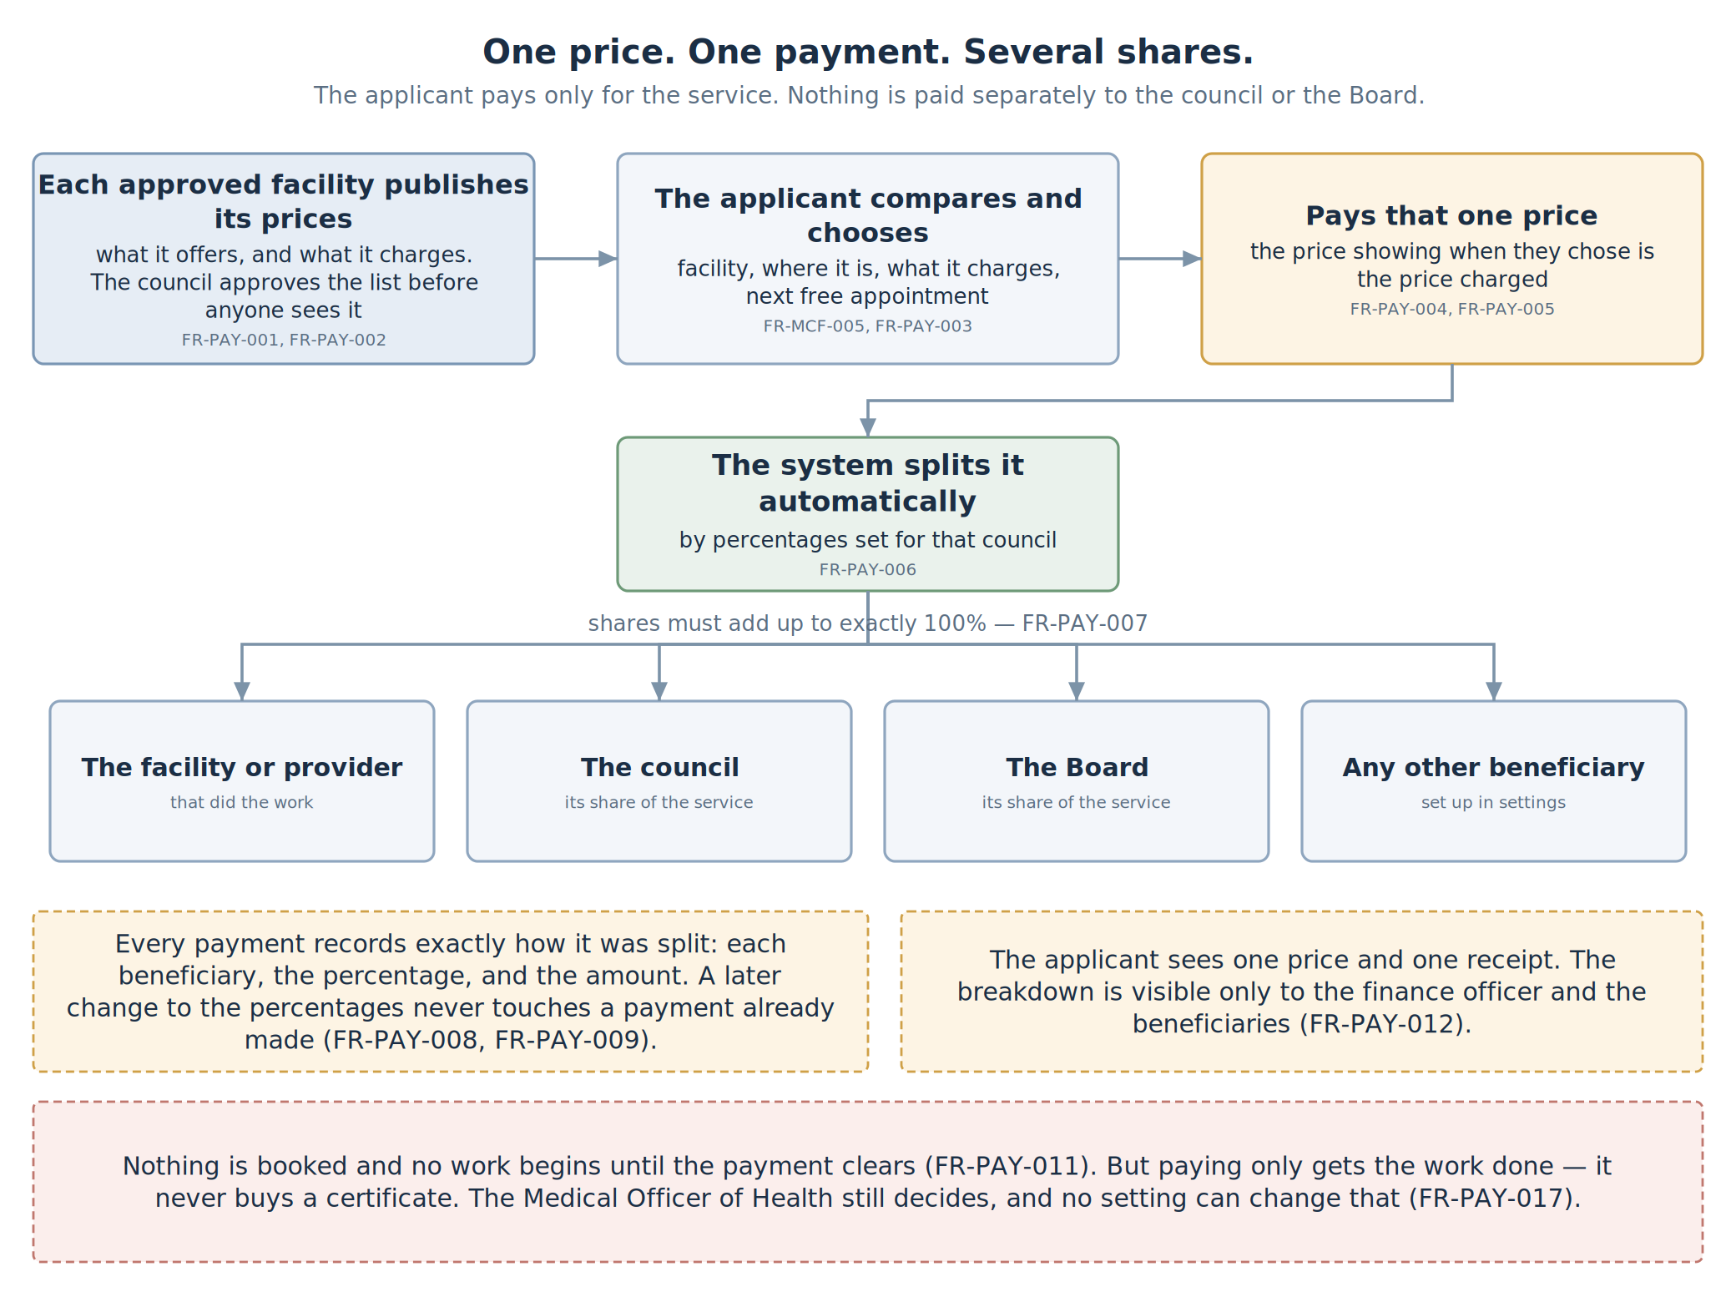
Figure 8 — One price, one payment, several shares.
Ref | The system must…
FR-PAY-001 | Hold a price list for each approved facility and licensed provider: each service, its price, and the dates the price applies from and until.
FR-PAY-002 | Require the council to approve a price list, and any change to it, before it is shown to anybody. Every version is kept, with who approved it and when.
FR-PAY-003 | Show the applicant the choices side by side — facility, where it is, what it does, what it charges, and when it can see them.
FR-PAY-004 | Charge the price that was showing when the applicant chose. A later price change never affects an application already made.
FR-PAY-005 | Take one payment for the service and nothing else. No other charge of any kind may be added.
FR-PAY-006 | Split each payment automatically into two or more beneficiary accounts by percentage. The percentages are set per council, and may differ by service and by facility.
FR-PAY-007 | Refuse to save a split that does not add up to exactly 100%.
FR-PAY-008 | Keep every version of the split, with its effective dates and who approved it. A change never affects a payment already made.
FR-PAY-009 | Record, on each payment, exactly how it was split: every beneficiary, their percentage, and their amount in naira.
FR-PAY-010 | Follow a set rounding rule so the shares always add back to the exact amount paid, with any odd kobo going to one nominated beneficiary.
FR-PAY-011 | Hold the appointment until payment is confirmed. Nothing is booked and no work starts before then.
FR-PAY-012 | Issue a receipt with a barcode showing what the applicant paid. The applicant sees one total. The breakdown is visible only to the finance officer and the beneficiaries.
FR-PAY-013 | Support refunds, reversing each beneficiary’s share in proportion. When a refund is due is a council setting. [confirm the refund rules — Q3]
FR-PAY-014 | Support waivers, where somebody is not to be charged. A waiver needs a second person to approve it, and the officer deciding the application may never be that person.
FR-PAY-015 | Reconcile what the payment channel says was collected against what the system recorded, and flag anything that does not match.
FR-PAY-016 | Report what was collected and what was paid out, by beneficiary, service, facility, council, and period.
FR-PAY-017 | Never let a payment cause a certificate to be issued. Payment gets the work done; the MOH decides the outcome.
FR-PAY-018 | Never store card or bank details. Only the payment channel handles those; this system keeps the reference and the result.

10. Settings each council can change
The system is being built for two councils but should be usable by any of them, and by other bodies later. So anything that could reasonably differ from one council to another is a setting rather than something written into the software.
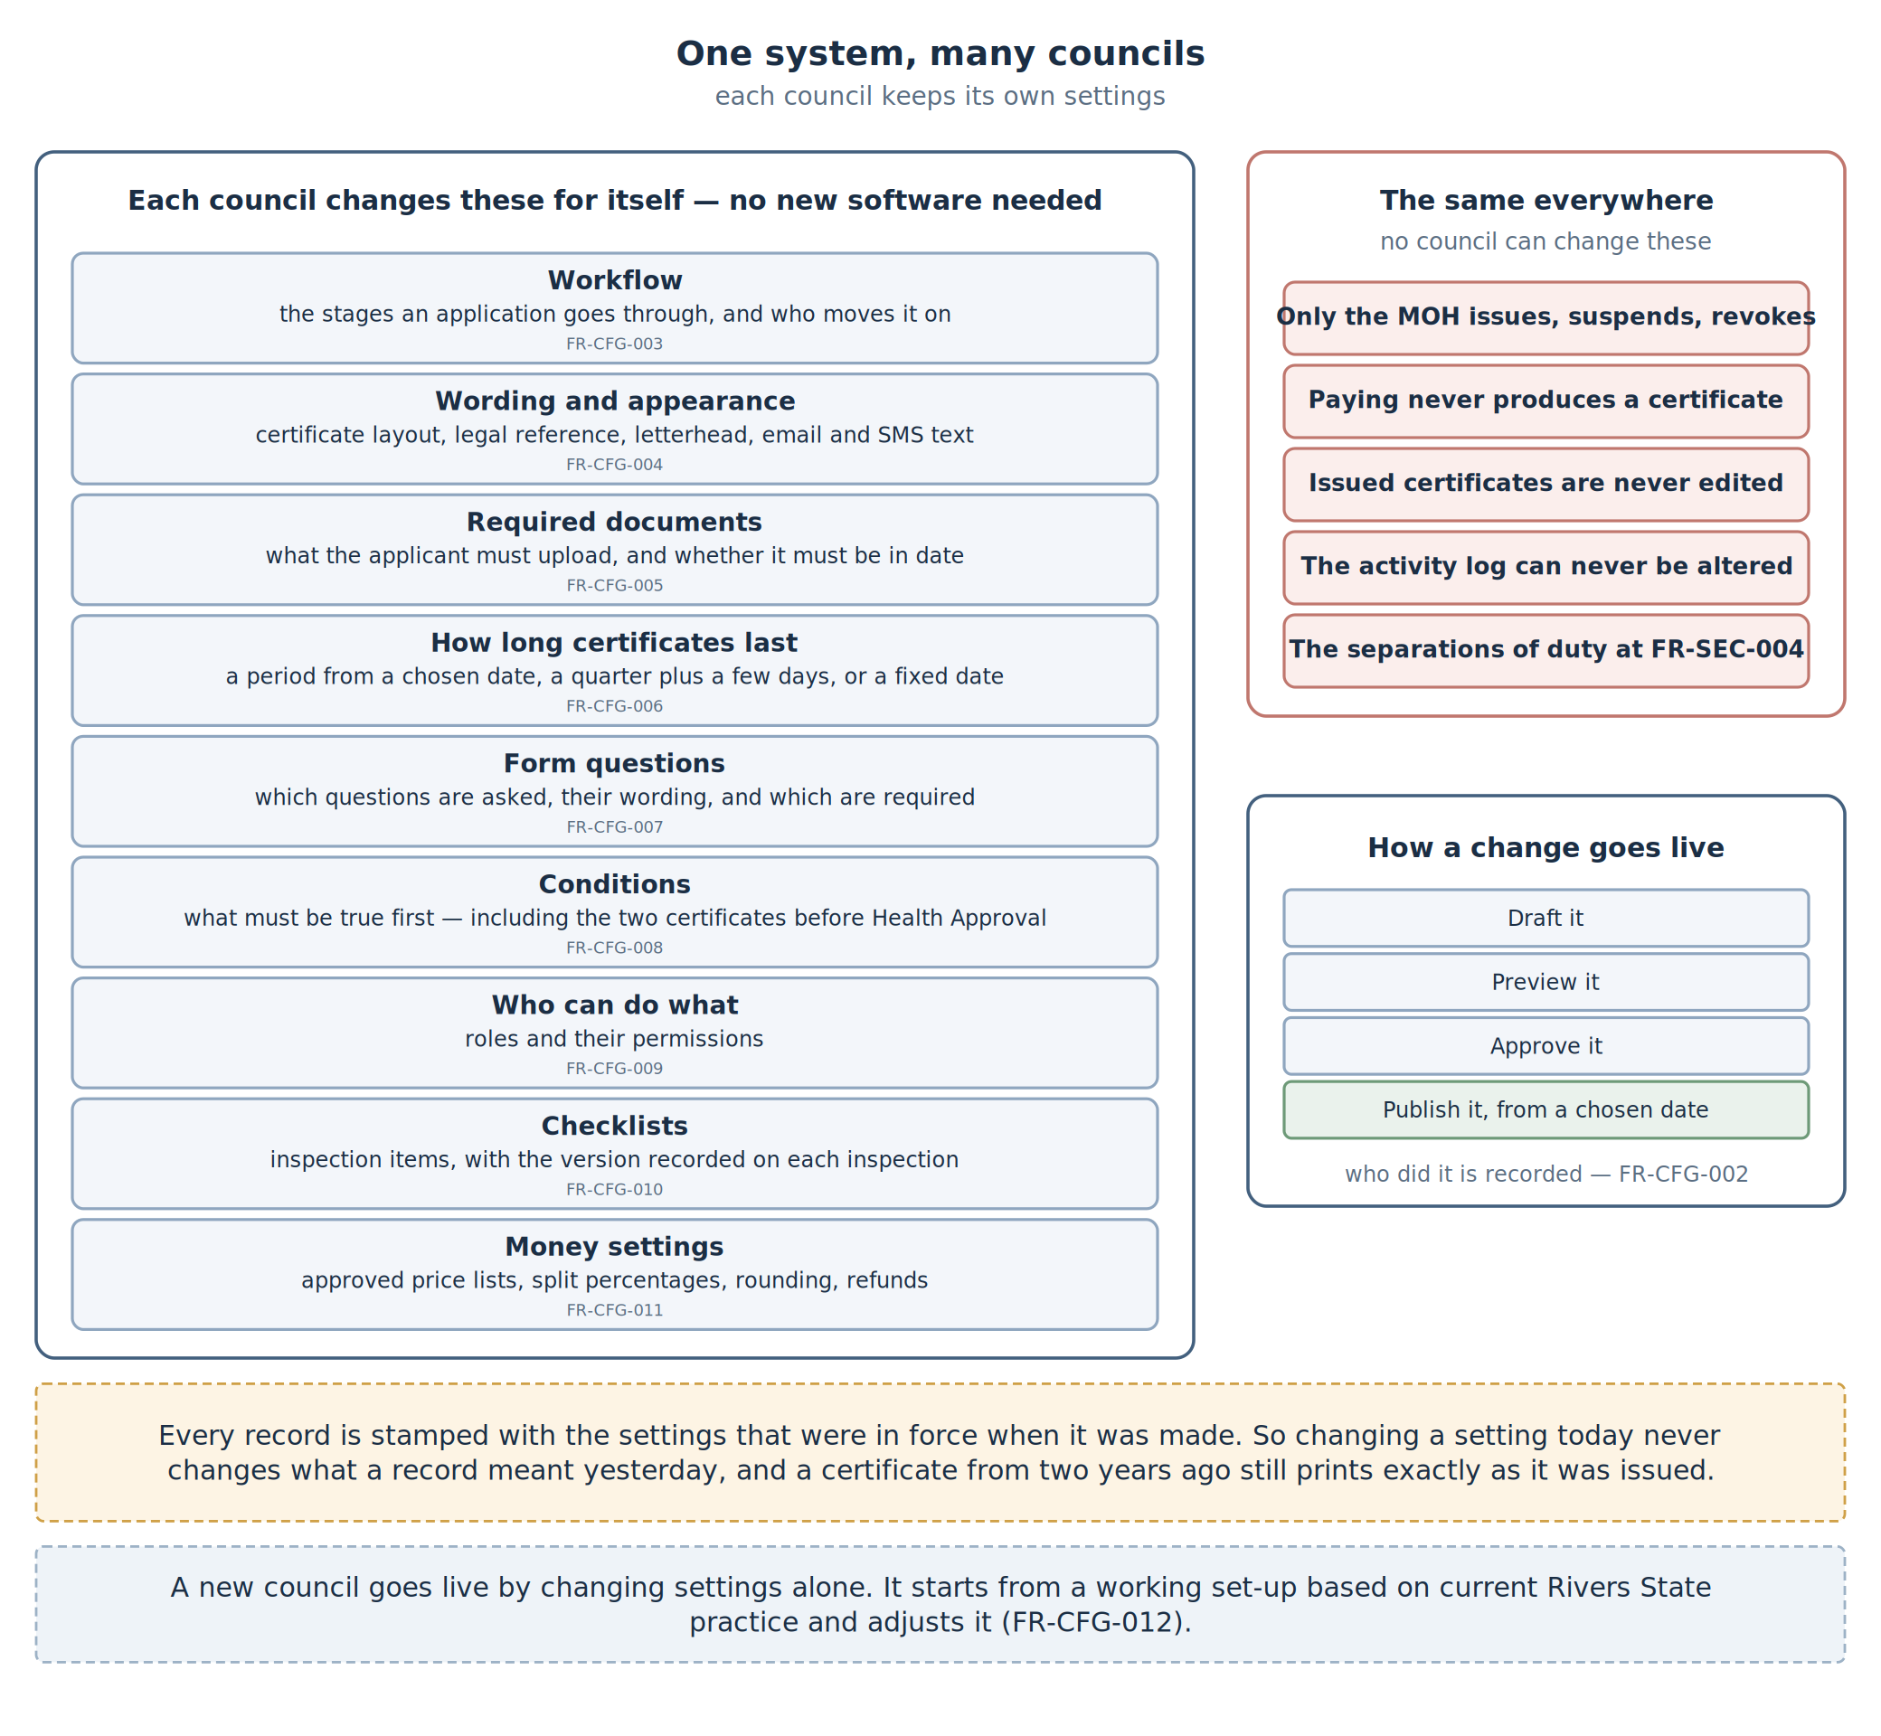
Figure 9 — What a council controls for itself, and what is fixed everywhere.
Ref | The system must let a council change…
FR-CFG-001 | Its own space. Every record belongs to one council, and every setting is looked up against that council.
FR-CFG-002 | Its settings safely. Changes are drafted, previewed, approved, then published with a start date. Who published what, and when, is recorded.
FR-CFG-003 | Workflow. Which stages an application passes through, who may move it on, and where a password must be re-entered.
FR-CFG-004 | Wording and appearance. Certificate layouts, legal references, warning text, letterhead and crest, reference number format, and the wording of emails and text messages.
FR-CFG-005 | Required documents. Which supporting documents an applicant must supply, whether each must be in date, and whether an officer must check it before the application moves on.
FR-CFG-006 | How long certificates last. A fixed period from a chosen date, a quarter plus a few days, or a fixed calendar date — plus how far ahead reminders go out.
FR-CFG-007 | Form fields. Which questions are asked, their labels, help text, whether they are required, and the order they appear in — and any field added this way can still be reported on.
FR-CFG-008 | Conditions. What must be true before something can happen, including the rule that Health Approval waits for the other two certificates. A council may add conditions, never remove a safeguard.
FR-CFG-009 | Who can do what. Roles, their permissions, and how far each reaches.
FR-CFG-010 | Checklists. The inspection items and their versions. Each inspection records which version was used.
FR-CFG-011 | Money settings. Approved price lists, the split percentages, the rounding rule, and refund rules.
FR-CFG-012 | Start-up. Settings can be exported and imported, so a new council starts from a working set-up and adjusts it rather than starting from nothing.
Five things no council can change. Only the MOH issues, suspends, or revokes. Payment never causes issuance. An issued certificate is never edited. The activity log can never be altered or deleted. And the separations of duty at FR-SEC-04 always hold.

11. Screens and outside connections

11.1 Screens
Screen | For whom | What it does
Public portal | Applicants and food handlers | Apply, upload documents, compare and choose a facility, pay, book, track progress, renew, get receipts. Works on a cheap phone
Check page | Anyone | Scan a barcode or type a code and see whether the document is real and valid. No login
Facility screens | Approved facilities | Publish services and prices for approval, offer appointment times, record results, upload lab documents
Provider screens | Licensed providers | Publish services and prices, offer dates, file job reports
Field app | Officers | Inspection list, notices and whether they were acknowledged, offline checklists with photographs, the whole picture of a premises, barcode scanning
Officer console | MOH, Director, supervisors | Approval queues, the Health Approval eligibility list, issuing, suspending, revoking, reporting
Finance console | Finance officers | Price list approval, split percentages, reconciliation, refunds, waivers, reports
Settings console | Settings administrators | Everything in Section 10, with draft, preview, approve, publish

11.2 Devices and outside systems
Ref | Requirement
FR-EXT-001 | The field app runs on an ordinary Android phone or tablet.
FR-EXT-002 | Field and counter devices scan barcodes with the device camera.
FR-EXT-003 | The field app takes photographs as evidence, recording when each was taken. [whether to record location too still needs deciding — Q14]
FR-EXT-004 | Certificates and receipts print properly on A4, and the barcode still scans after printing and photocopying.
FR-EXT-005 | A payment channel is required, able to take the payment, return a reference, split it or support the system splitting it, and provide settlement data. [which channel — Q1]
FR-EXT-006 | An SMS gateway and an email service are required for notices, acknowledgement links, and reminders.
FR-EXT-007 | Laboratory systems, identity checking, and business registration systems may be connected later. They are not needed for this release.

12. Quality requirements

12.1 Who can do what
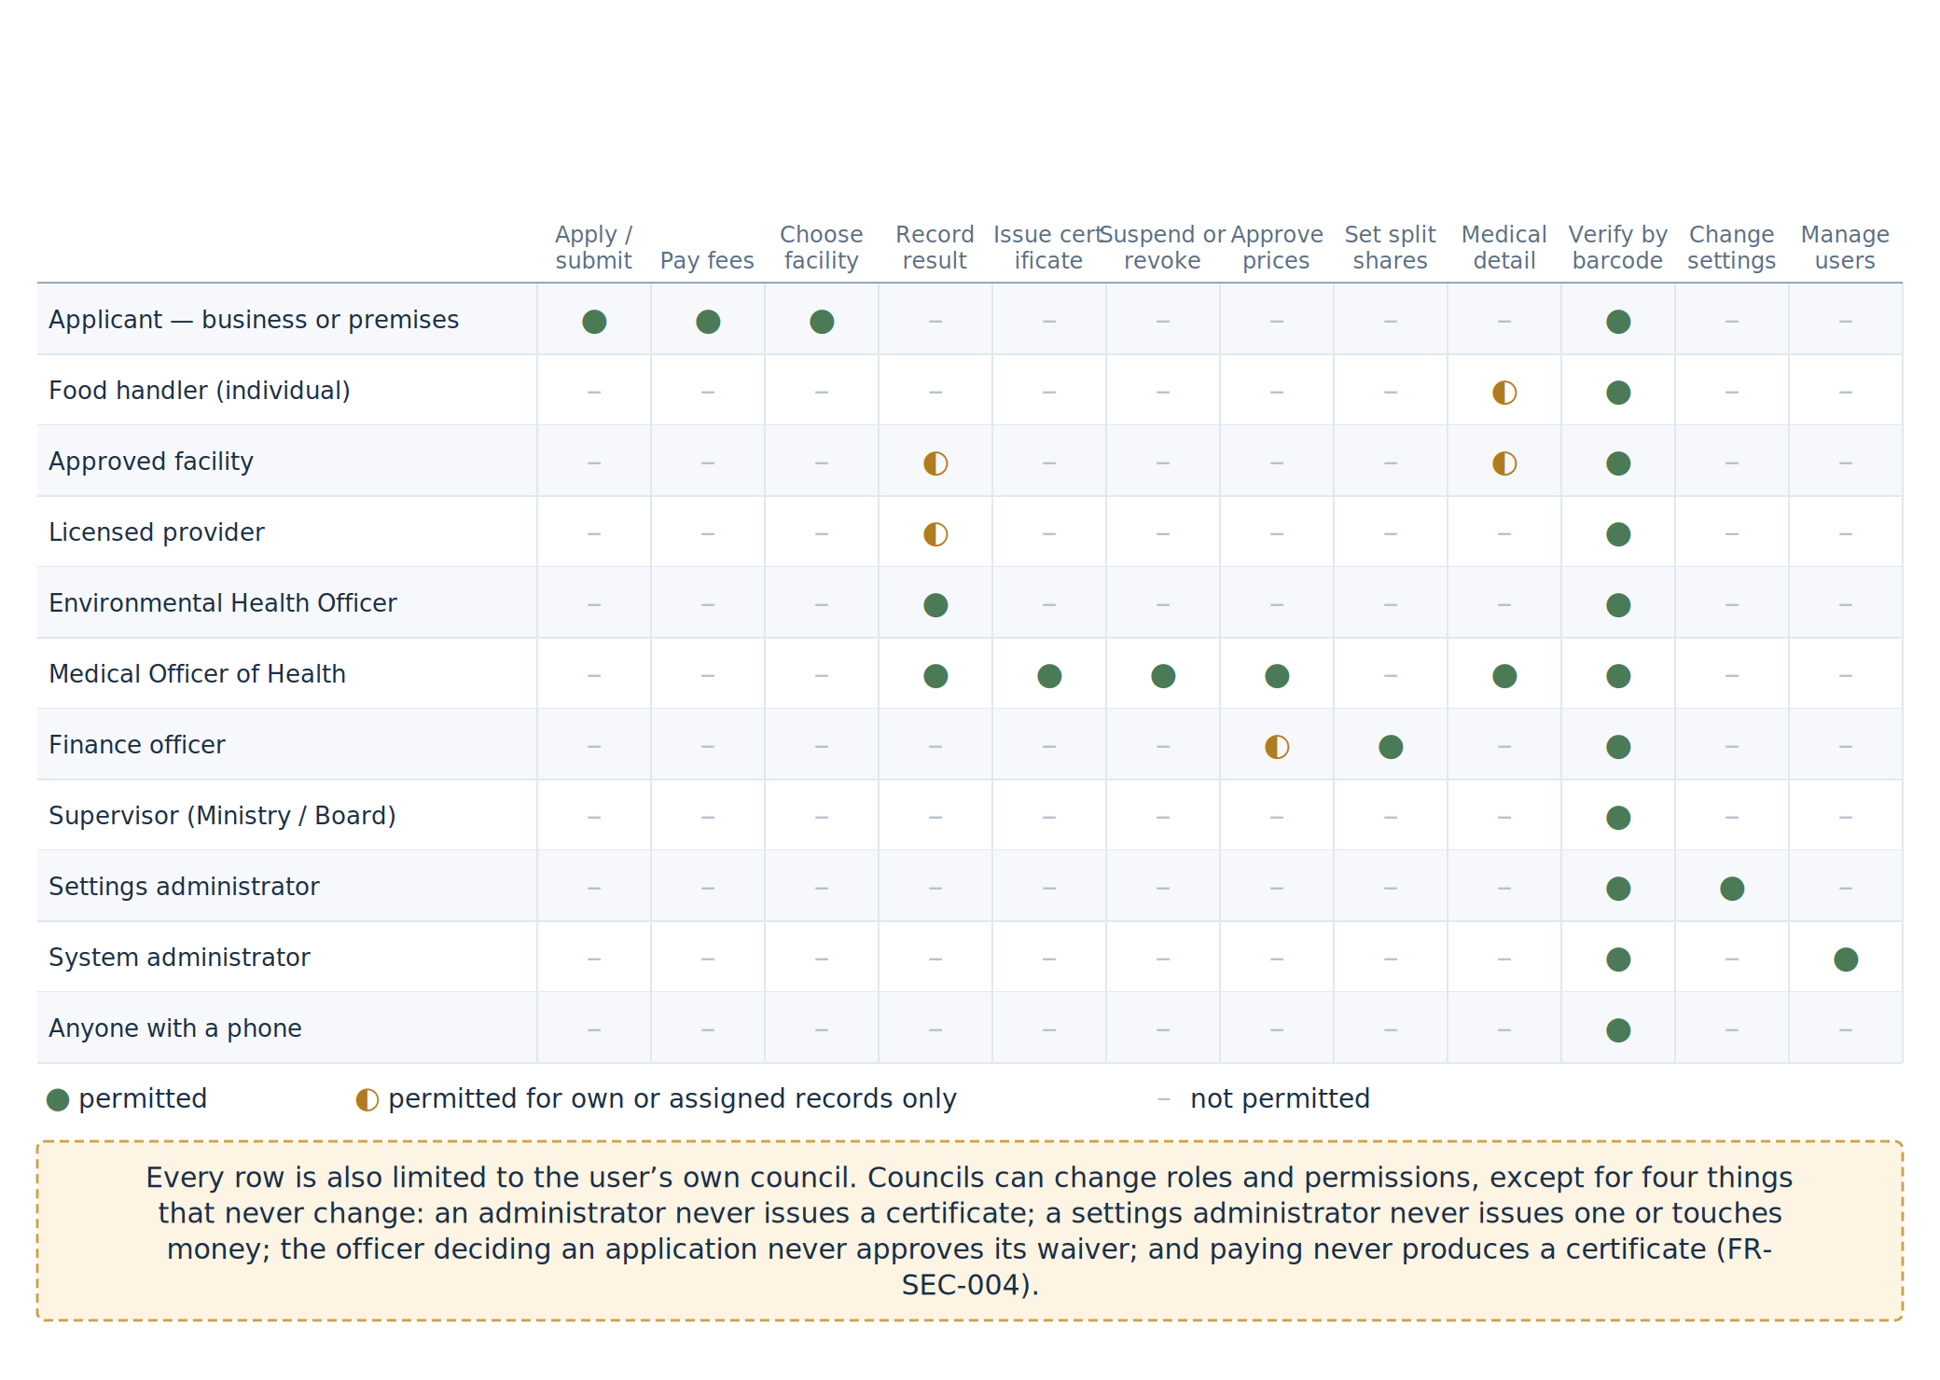
Figure 10 — Who can do what. Every row is also limited to that person’s own council.
Ref | Requirement
FR-SEC-001 | Permissions are by role, and also limited to the user’s own council unless they hold a supervisory role.
FR-SEC-002 | Issuing, suspending, revoking, and withdrawing are restricted to the MOH or Director, who must re-enter their password at that moment.
FR-SEC-003 | Anyone who can issue, approve prices, approve waivers or refunds, or publish settings must use two-factor sign-in.
FR-SEC-004 | Four separations always hold: an administrator never issues a certificate; a settings administrator never issues a certificate or touches money; the officer deciding an application never approves its waiver; and no payment ever causes issuance.
FR-SEC-005 | All traffic is encrypted. Health information, payment records, and evidence photographs are encrypted where they are stored.
FR-SEC-006 | Field devices encrypt what they hold and can be wiped remotely if lost.
FR-SEC-007 | The public check page is rate-limited and watched, so nobody can scrape the register.

12.2 Privacy
Food handler medical information is the most sensitive data in the system, and the person it belongs to is usually an employee of the person paying for the test. The design has to protect them from their own employer.
Ref | Requirement
FR-PRV-001 | Medical information is handled under the NDPA. The lawful basis must be written down before building starts, remembering that consent given through an employer may not count as freely given. [legal decision needed — Q15]
FR-PRV-002 | Collect only what is needed to decide fitness and identify the person.
FR-PRV-003 | Do not reuse medical information for anything else without a separate lawful basis.
FR-PRV-004 | Only the facility, the MOH, and the person themselves see medical detail. The employer sees fit or not fit, and nothing more.
FR-PRV-005 | A Data Protection Impact Assessment is required before go-live and must cover the medical data, the public check page, the field photographs, and the payment records.
FR-PRV-006 | Set and enforce how long each kind of record is kept. [periods to be confirmed — Q16]
FR-PRV-007 | Let people see their own record and correct factual errors, by re-issue rather than editing.
FR-PRV-008 | Have a written agreement with every facility, provider, and payment channel handling data on the department’s behalf, and record which version applies.
FR-PRV-009 | Show a plain-language privacy notice at the point information is collected.

12.3 The permanent record
Ref | Requirement
FR-AUD-001 | Record who did it, in what role, when, and why, for every issue, renewal, suspension, revocation, waiver, refund, price approval, and settings change.
FR-AUD-002 | Do the same for every inspection finding, deadline, notice sent, and acknowledgement received.
FR-AUD-003 | Make the log add-only. Nobody, including administrators, can change or delete it.
FR-AUD-004 | Fingerprint every photograph and attachment when it is taken, so later tampering shows.
FR-AUD-005 | Be able to reproduce any certificate exactly as it was issued, under the settings in force at the time, with the trail behind it.
FR-AUD-006 | Record separately when something was captured in the field and when it reached the server.
FR-AUD-007 | Be able to show how any payment was split and why those percentages applied.

12.4 Working offline, and speed
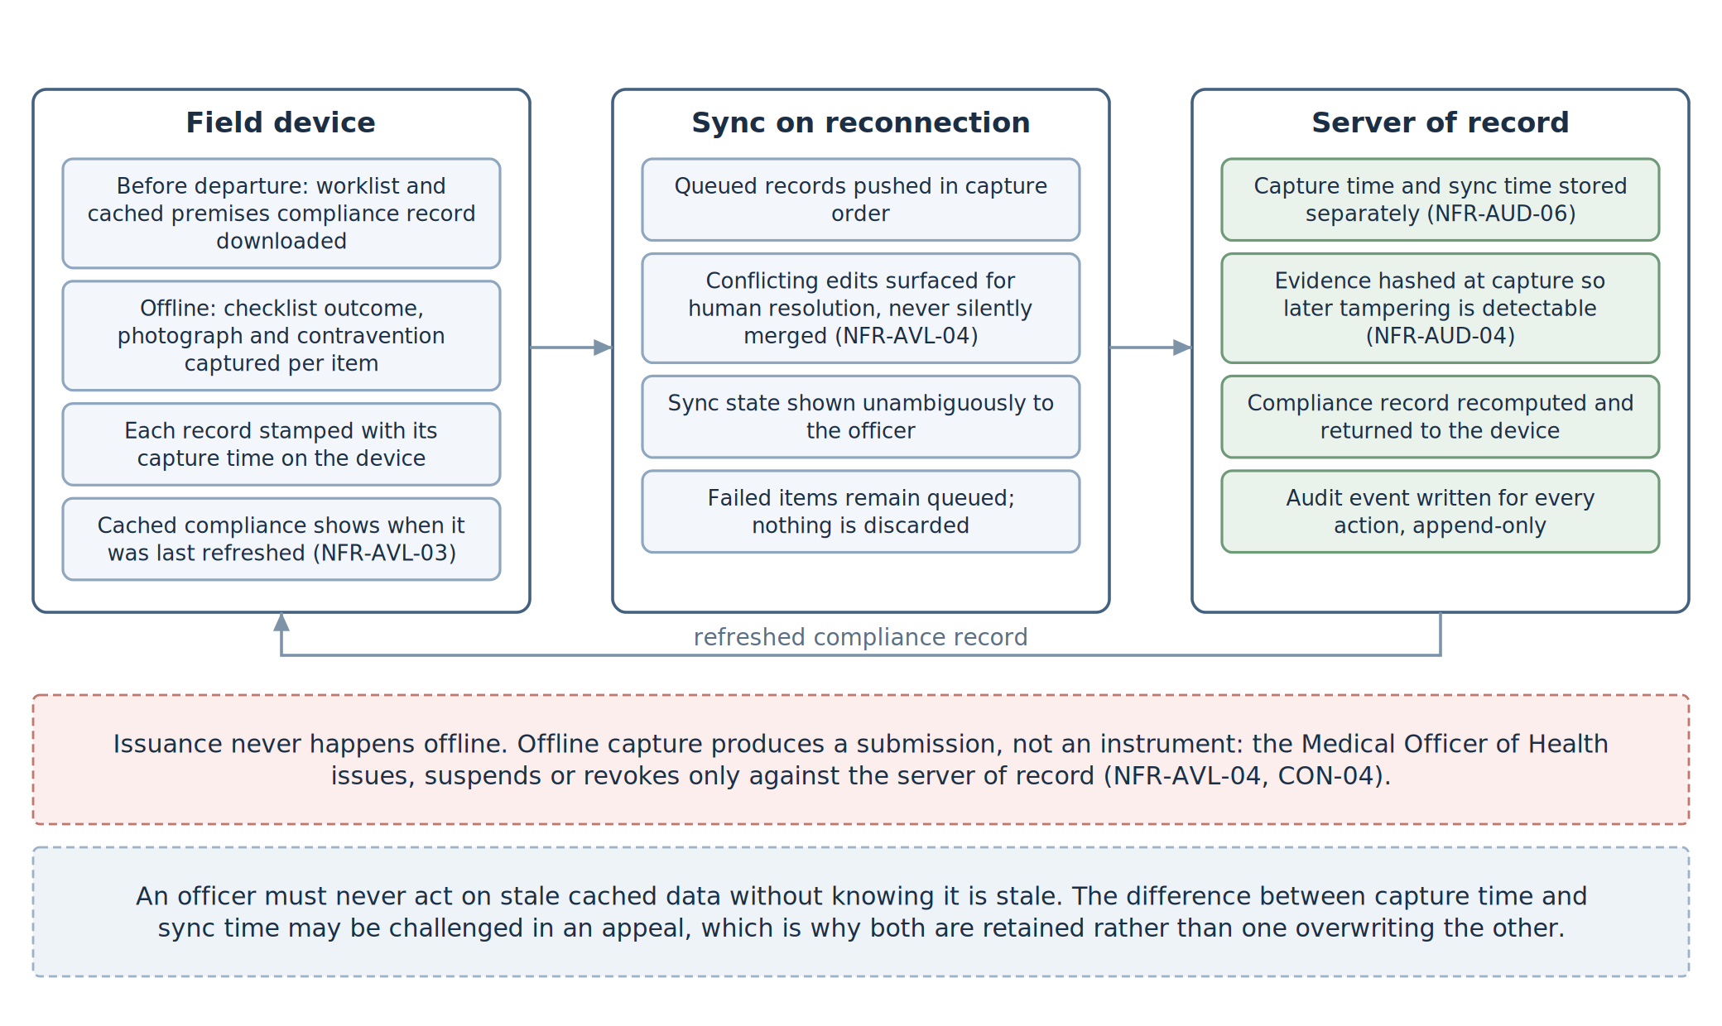
Figure 11 — Working without signal, and the line that must never be crossed.
Ref | Requirement
FR-AVL-001 | The field app works with no signal at all: the day’s list, the checklists, photographs, and findings.
FR-AVL-002 | It shows when its copy of the data was last refreshed, so an officer knows if it may be out of date.
FR-AVL-003 | It uploads when signal returns, shows clearly what has and has not gone up, and never merges conflicting entries silently.
FR-AVL-004 | Nothing is ever issued offline. Work done in the field becomes a submission for the MOH to decide on, never a certificate.
FR-AVL-005 | The public check page is the most reliable part of the system and answers within about three seconds.
FR-AVL-006 | If the payment channel is down, the application simply waits. Nobody may push it forward by hand.
FR-AVL-007 | The system copes with every regulated premises in the participating councils being inspected each quarter. [how many premises — Q17]
FR-AVL-008 | Target availability during working hours is 99.5%.

12.5 Ease of use
Ref | Requirement
FR-USE-001 | Everything an applicant needs works on a cheap smartphone over a slow connection.
FR-USE-002 | Applicant screens avoid legal and technical language. Every question explains itself.
FR-USE-003 | A counter officer can fill in an application for someone, and is recorded as having done so.
FR-USE-004 | The price is shown in full before payment. Nothing is added afterwards.
FR-USE-005 | The field checklist can be used one-handed, outdoors, in bright sun.
FR-USE-006 | Printed certificates still look like the documents people already recognise.

13. Information the system keeps
This section is mainly for the development team. Each box below becomes a table in the database, and the lines between them are what makes the rest of the document possible.
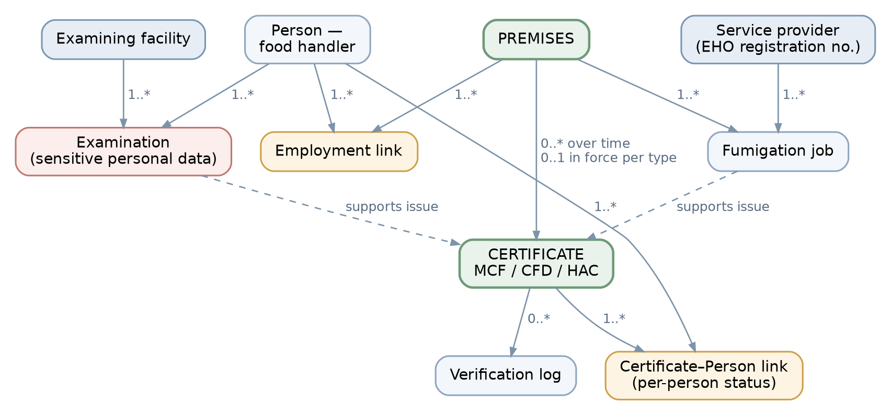
Figure 12 — People, premises, and certificates.
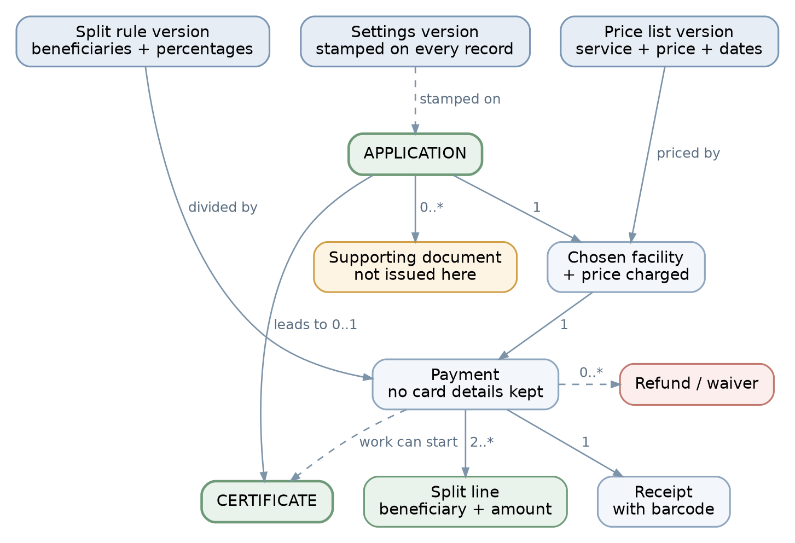
Figure 13 — Applications, prices, payments, and settings.
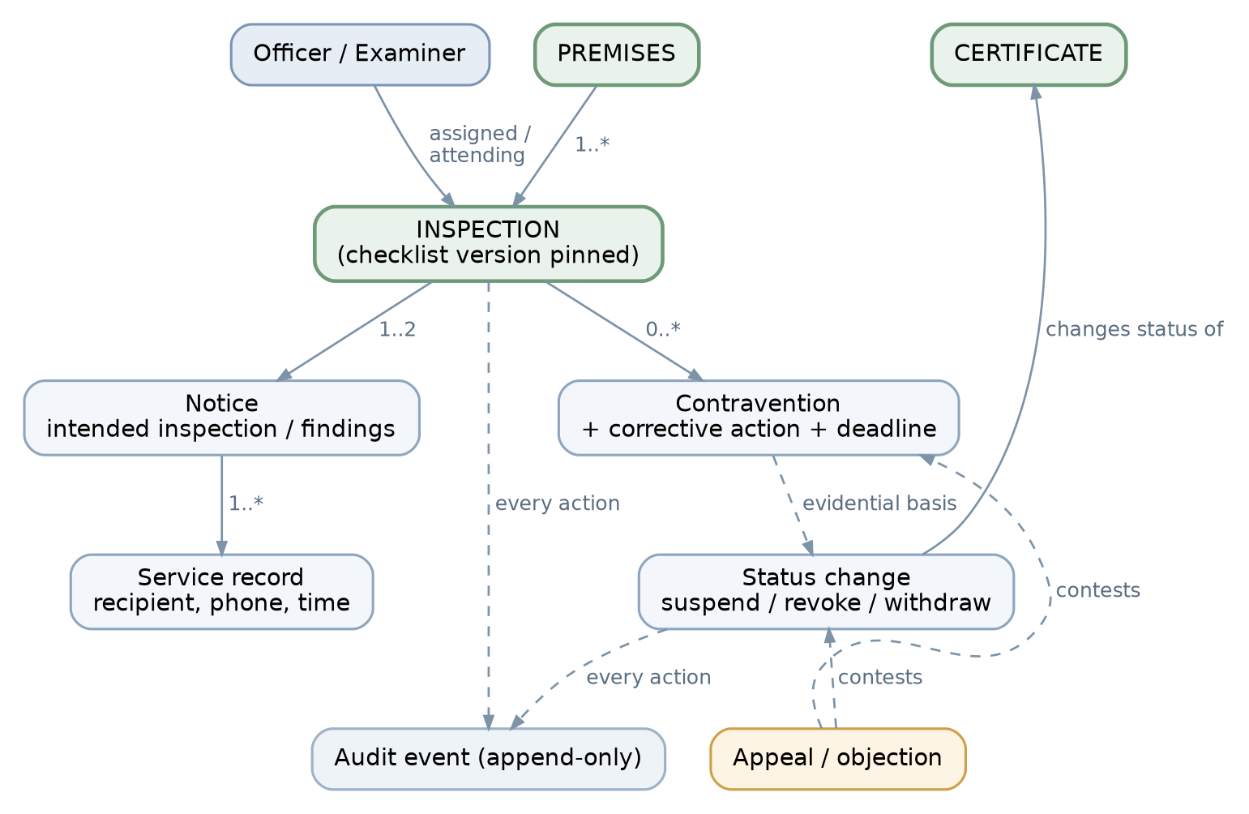
Figure 14 — Inspections and enforcement.
What is stored | Main details | Why it matters
Council | Code, name, parent body | Everything belongs to one council
Settings version | Council, version, dates, who approved | Stamped on every record
Premises or business | Number, trading name, address, ward, council, type, owner, contacts | The centre of everything
Person | Number, name, sex, date of birth, identity number, phone | Stands alone, not tied to one employer
Works-at link | Person, premises, start and end dates, job | Drives the Health Approval rule
Application | Type, subject, who applied, date, stage, settings version | One per certificate wanted
Supporting document | Type, reference, who issued it, dates, scan, who checked it | Not produced here
Facility | Name, address, location, services, approved prices, approval dates | Shown to the applicant to choose from
Provider | Registered name, EHO number, address, services, prices, licence dates | Same
Price list version | Facility or provider, service, price, dates, approver | Never edited once used
Split rule version | Council, service, beneficiaries and percentages, dates, approver | Must total 100%
Payment | Application, amount, channel, reference, payer, date, status | No card details ever
Split line | Payment, beneficiary, percentage, amount | Recorded as it was applied
Receipt | Payment, number, barcode | Can be checked publicly
Officer | Name, post, office, role, signature block
Appointment | Application, facility or provider, date and time, acceptance
Examination | Person, facility, clinician, date, tests, result, restricted attachments, consent | The most sensitive record
Fumigation job | Premises, provider, supervising officer, date, pests, methods, report
Certificate | Type, number, reference, barcode, subject, three dates, expiry rule used, issuing officer, council, status, settings version | The legal document
Certificate–person link | Certificate, person, that person’s status | Lets one person be revoked alone
Notice | Type, inspection, reference, barcode, date, content as sent
Service record | Notice, channel, address used, sent time, delivery, acknowledgement | Proof it was served
Inspection | Premises, kind, notice, date, officers named and attending, checklist version, results, photographs | Cannot exist without a notice
Contravention | Inspection, item, what is wrong, what must be done, deadline, outcome
Status change | Certificate, from and to, reason, note, effective date, officer, time
Objection | What is being contested, grounds, attachments, outcome
Check log | What was checked, when, by whom, what was returned
Activity log | Who, what, when, before and after | Add-only
Three points the developer should not miss. A premises can hold many certificates of a type over the years but only one that is currently valid, and working out which one that is needs the status and the dates, because a withdrawal can be backdated. Health Approval eligibility is worked out fresh each time, never stored as a flag, or it will go stale. And every record carries its settings version, which is what makes it possible to reprint a two-year-old certificate exactly as it was.

